 Visual Guide

by Jinn (with minor additions by Andrettin)

Introduction:
The game's graphics reflect the mythological world incorporated in Wyrmsun's story, a mixture of fantasy, antiquity and the middle ages.

Portraits
They are the most detailed manner of presenting the characters, abilities, technologies and items of Wyrmsun's world; the artistic style is pixel art, as with nearly all the other assets of the game. The graphics have the exact size of 46x38px and a maximum palette of 256 colors in total, 4 of them being team-colors; generic shades which change according to the player's faction. The team-color can be applied to the character's clothing, to war painting, to the background of the portrait, etc. The portraits tend to comprise the most important part of the subject in question; if it is a unit, use the face or bust; if it is a technology, something that exemplifies or symbolizes it; if it is a spell or ability, a graphic demonstration of it being used or of its effects; if it is an object, a piece of it or, if possible, it in its entirety.
Artistic style:
The portraits have a lightly cartoonish artistic style, but with realistic shading.
This style allows better exploring facial characteristics, such as eyes and mouths; or behavioral ones, such as exaggerated expressions (should it be interesting to demonstrate the personality of the subject character); and poses (such as forcing the perspective in order to make the hand or weapon appear together with the face).
The realistic shading is very important to help balance the cartoonish style with the more serious themes addressed in the game).
Examples:
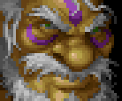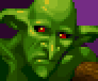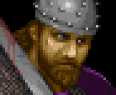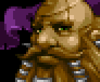
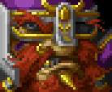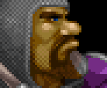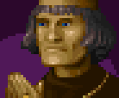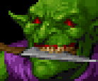
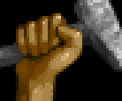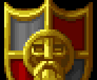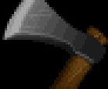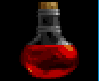
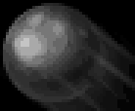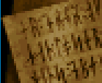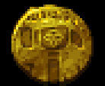
Creation tips:
When replicating the artistic style, try always to maintain a soft and punctual shading. Work with ambient lights; avoid, at all costs, Pillow-shading. The shading should be very soft, avoid very abrupt changes of shades, and should it be necessary, create intermediary colors to help with the gradient's blend. Colors should not be affected by lighting, either directly or indirectly (ex: a portrait cannot be portrayed under colored lighting; what is gray is gray, what is brown is brown, what is green is green, etc.). Texturas são encorajadas, mas evite torna-las muito fortes, à ponto de conflitar com o sombreamento suave de peles/panos/metais. Texturas podem ser aplicadas, por exemplo, em cabelos, barbas, chainmails, desgastes de uso, etc.
Exemplos do processo de criação:
Comece definindo o enquadramento e a forma geral do portrait, defina os pontos de luz e sombra, e então comece a mesclá-los com as cores da paleta. Por fim, aplique os detalhes adicionais.
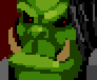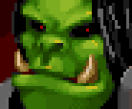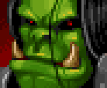
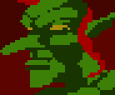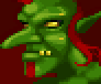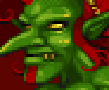
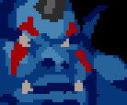 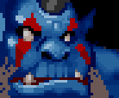 
Recomended palette:
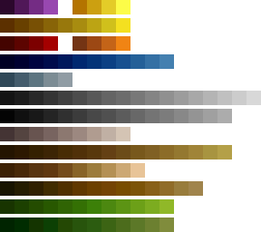
As you may notice, the colors begin and end without the hue varying much, this is a very important identity of the game's colors.
Remember: you can always create new colors for material that don't match any of the listed gradients, but try to mantain consistency with the rest of the gradients; New shades can be created should they be necessary (to soften shading, for instance).

Object-Specific Guidelines

Swords should be laid horizontally, with the intersection between the hilt and the blade featuring prominently. By showing the hilt in the portrait it becomes easier to represent the differences between swords of various cultures which have similar blades.

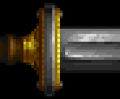
To differentiate the portraits of spear and javelin projectiles, spears should be angled upwards, while javelins should be angled downwards. "Stand ground" icons display two crossed weapons (usually two of the same weapon), both angled upwards.

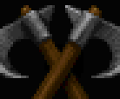
Structures
The game's structures can be represented in 3 different sizes:
Large: 128x128px
Medium: 96x96px
Small: 64x64px
The structures normally possess two frames, one of them being for it under construction, and the other for it completed. The final images are composed in the following manner: The structure's completed frame is placed above, while the under construction frame is placed below. Each structure has two image files, one for the structure itself, and the other one for its shadows. Like this:
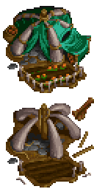 |  | 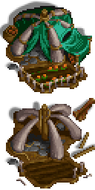
primary file | + file with the shadows | = in-game result

Like the portraits, structures also make use of team-color. It can be applied to cloth, paintings, etc.

Artistic style:
The structures are made in an "isometric" projection with Foreshortening (example B). Given that it is an isometric projection, the structures are viewed practically from above, and have a standard lighting that comes from the lower-right, that is, the shadows are always applied at the back of the structures being directed to the upper-left.
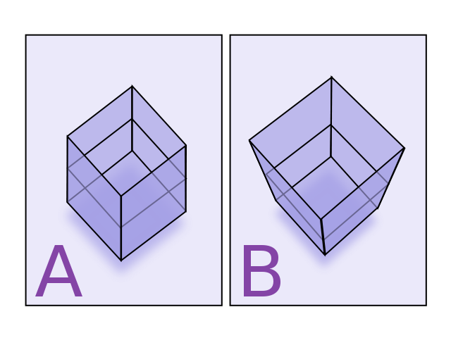
The structures can be rotated in their central axis, as long as the rotation values the structure as a whole (or is necessary to fit the canvas). Give preference, however, to the front of the structure being turned toward the player.
Tip: The taller the structure, the greater the effect of foreshortening should be. That helps a lot in the illusion that the structure distances itself from the ground, despite the projection being 2D.

Examples:

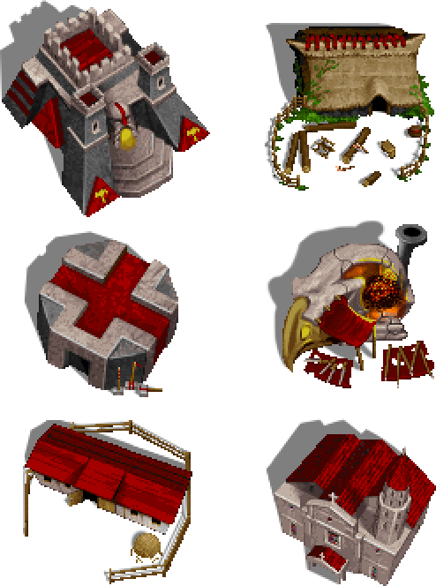

Creation tips / Creation process examples:
Sketching the structure in a 3D program (such as Google Sketchup) can be a good way of maintaining a good geometric consistency, and likewise of finding the ideal angle without having to redo the same drawing multiple times.
For the shading, feel free to use textures and good lighting in abundance (maintaining the standard of the other structures). Always try to place elements that represent the structure's purpose (for example: put logs and axes in a lumber mill, hay and fences in stables, weapons and anvils/furnaces in a smithy, etc.).
The scale of structures is flexible, but try to maintain a standard as well, don't create doors or windows that are too incompatible with those of the other structures. That helps to maintain the immersion and the homogeinity of the graphics.
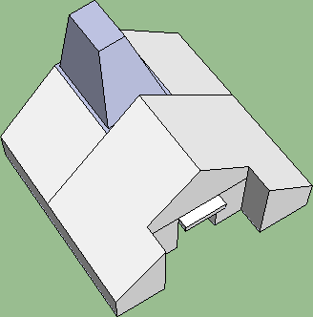 > 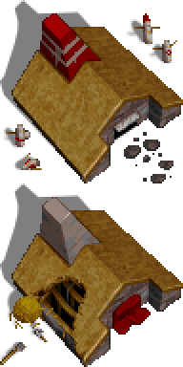

More detailed sketches can be of GREAT help to build more complex structures: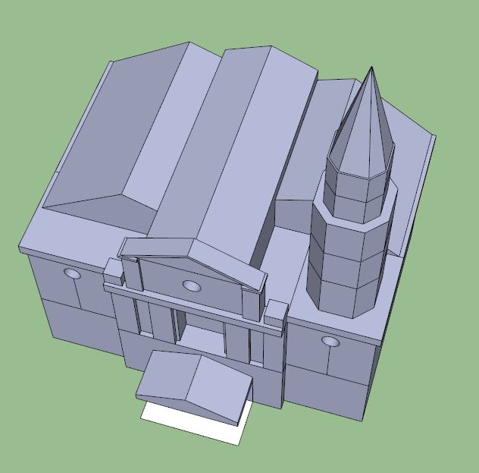

The under construction frame should give the idea that the structure is not yet ready for being used, while also making it clear to the player (and the opponents) which structures is being built (that is, the stage of construction represented shouldn't be a too early one). The construction of all buildings begins from two fixed frames used regardless of structure or faction; And, when being destroyed, they also use two fixed frames:

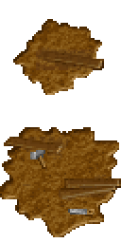 | 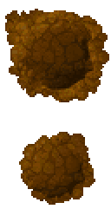
Under construction frames | Destruction frames

Unidades
Eu imagino que seja interessante também abranger a criação das unidades, mas eu não tenho muito know-how para falar sobre as etapas de criação ou sobre os detalhes técnicos como projeção, rotação, etc. Talvez o b_O possa falar melhor sobre isso?

